Name – Kamal Dilip Kumar Agrahari Subject – DevOps Lab

ID -VU4F2223028 TE IT A | Batch B

**Experiment No. 6**

**Aim** - : Executing java pipeline programming and integration of GitHub with Jenkins.

**Theory** –

Java pipeline programming refers to automating the process of building, testing, and deploying Java applications using Jenkins' Pipeline feature. Jenkins Pipelines are defined in a Jenkinsfile, which is a script that specifies the stages and steps of the continuous integration (CI) and continuous delivery (CD) process.

The JenkinsFile (Script file) is text file that defines the pipeline code, using Groovy-base syntax. It contains the stages and steps to execute for a Java Project

In our pipline, there are three stages

1. Checkout: In this stage the java program is fetched from our github repository
2. Build: In this stage the java porgram is compiled.
3. Test & Run: In this stage the compiled java program is executed and output is logged

**Steps**

1. Open Jenkins and create a new item/job. Name it anything you want and then select the pipeline option

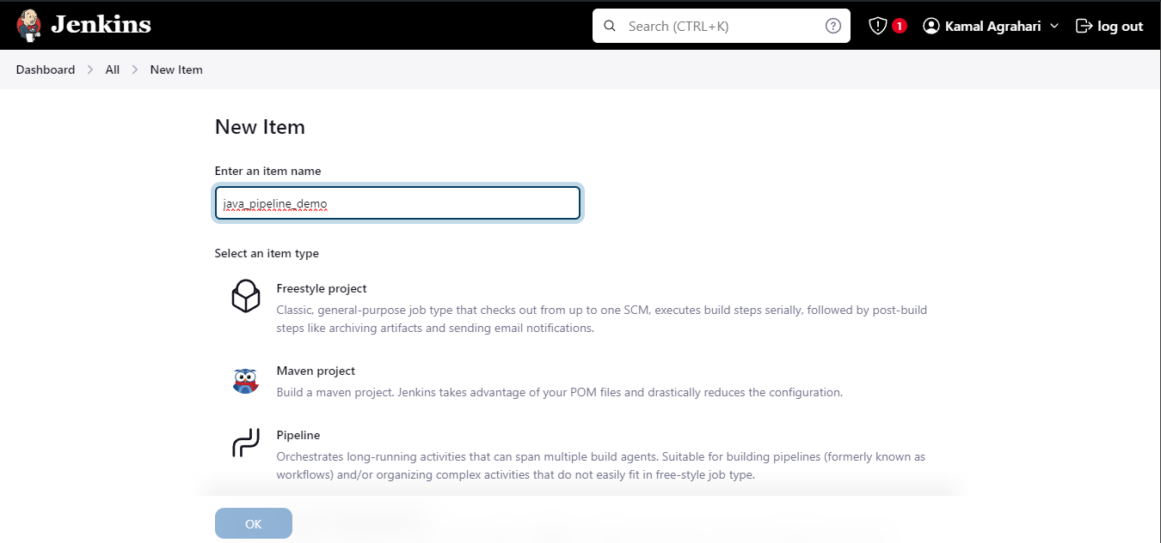

2. Open your pipeline item

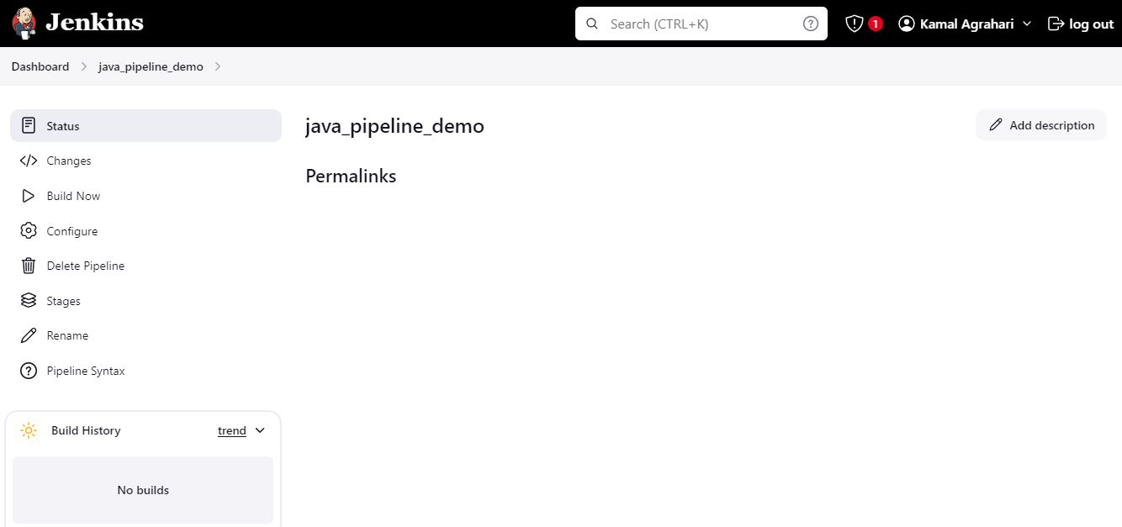

3. Go to Configure tab > then inside of it into Advance Project Options > In pipeline, in definition select pipeline script then in script area put your pipeline script.

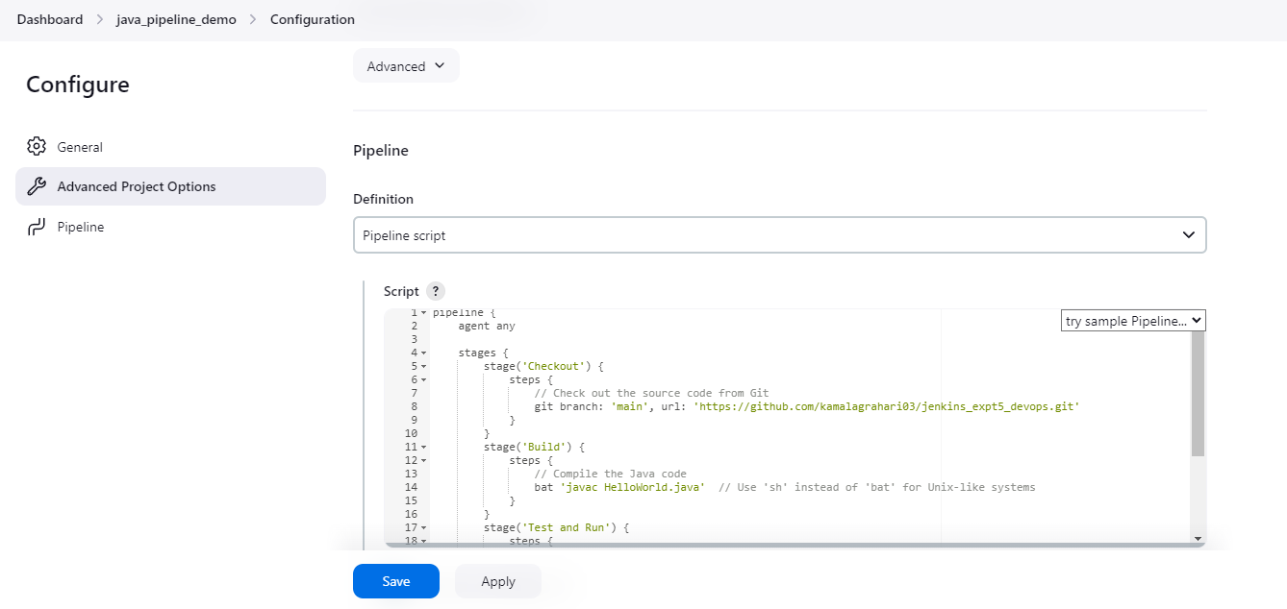4. Then save your changes and click on Build Now to execute your pipeline

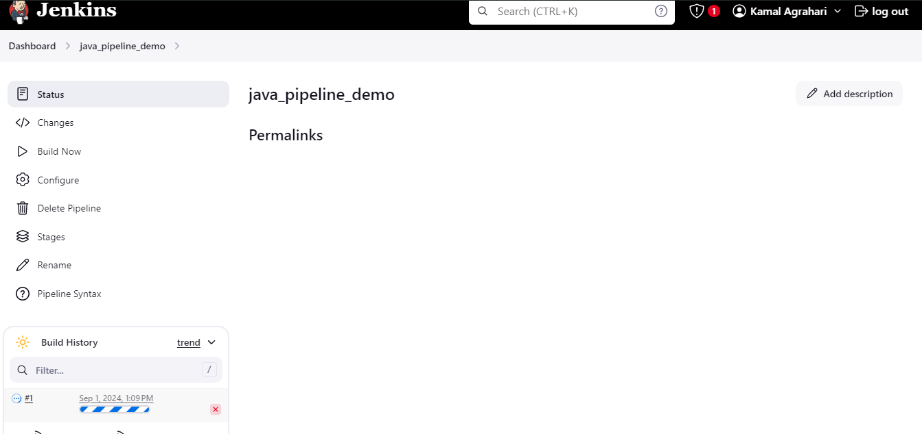

5. After you build is finished the overview results will be visible in Stage Vi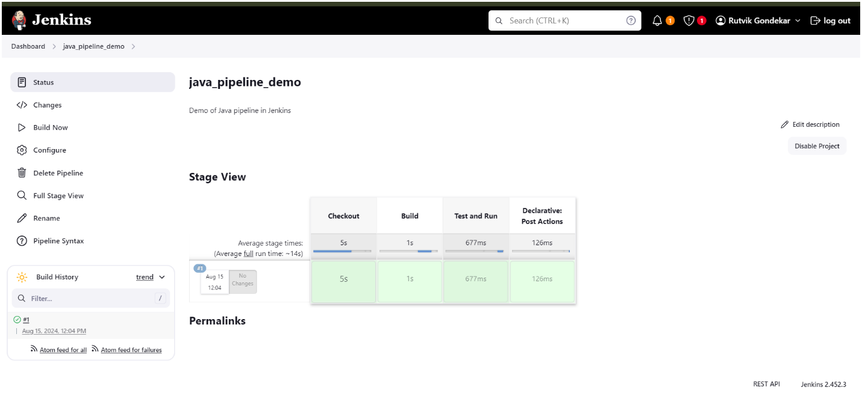

6. You can click on the build to see your console output

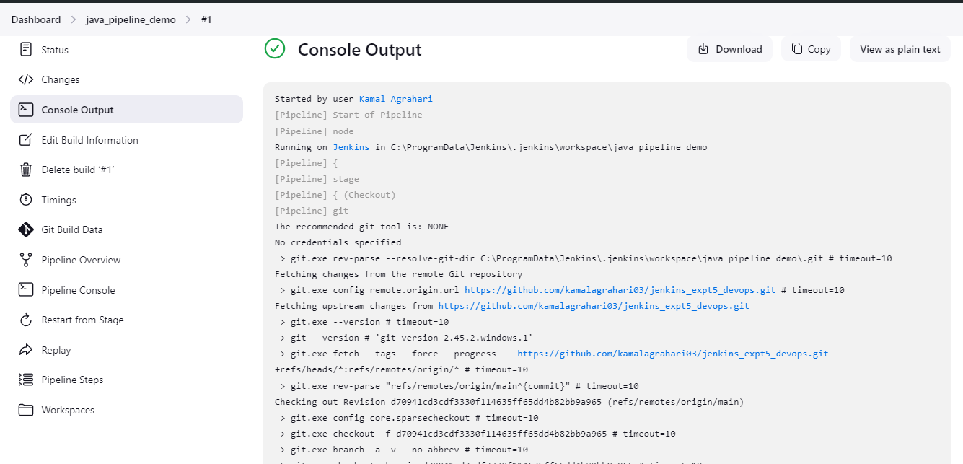

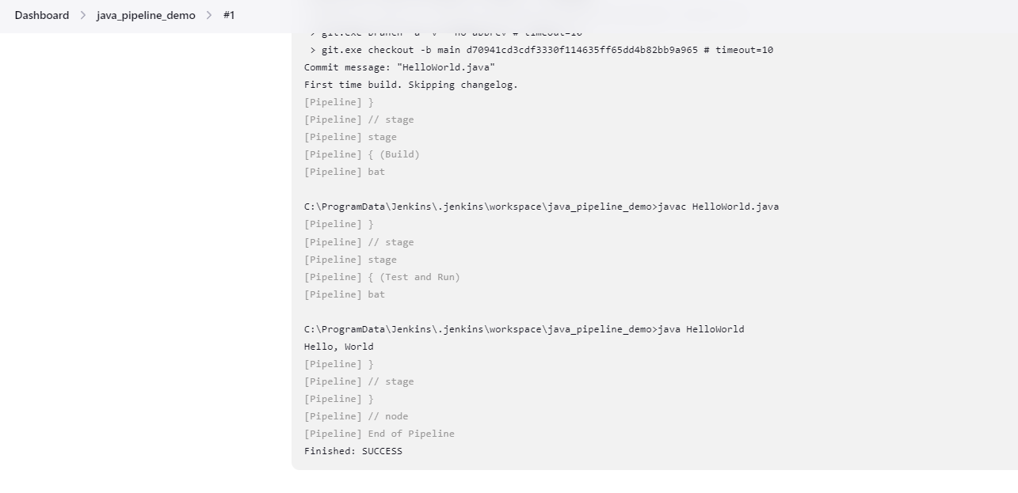

7. You can also checkout you step by step pipeline output in Pipeline Steps Tab

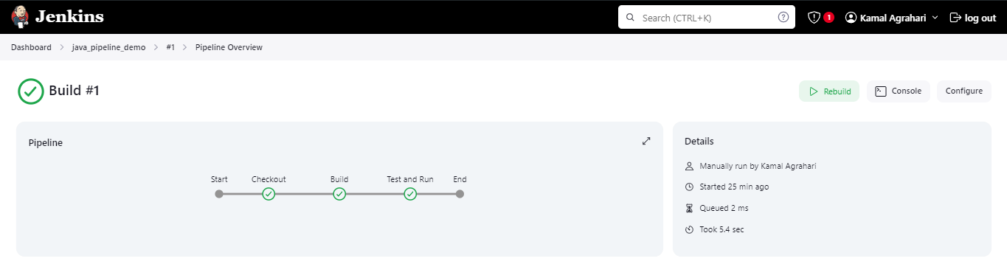

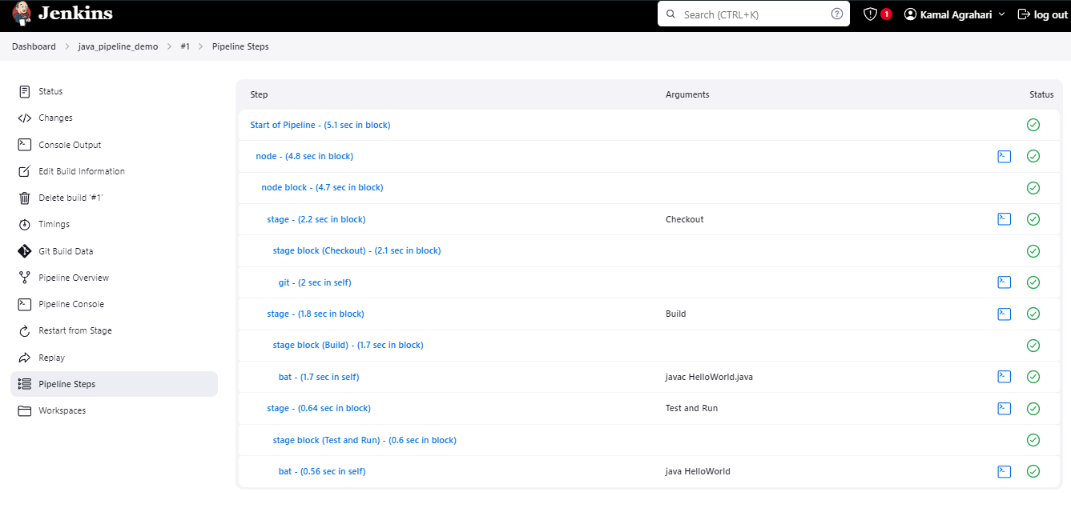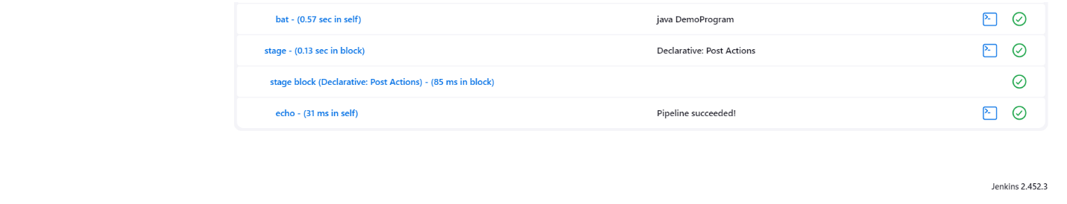

**Conclusion:**

Hence, successfully executed java pipeline programming in Jenkins integrated from GitHub.